GatorMart Documentation

February 4th, 2022

Sprint 1

Team Members:

Nitin Ramesh

Bhanu Prakash Reddy Palagati

Vamsi Krishna Reddy

Gowtham Reddy Eda

Introduction:

The GatorMart application is an online market build with Angular and Go language. Built from the ground up, the application aims to seamlessly connect buyers to their products and sellers to their target audience. Its standout features include allowing the users to select a target audience while buying or selling. This allows to buy products or sell products in single or wholesale quantities while specifying a target audience such as students, professionals, farmers, etc.

Tech Stack:

Frontend: Angular 11.0 with TypeScript

Backend: Go Language

Database: MySQL

Frontend:

The front end of the application is built using Angular 11. Angular is a framework rather than a package that provides all the essential functional requirements out of the box. This will force the developers to follow a pattern, as a result, we have fewer decisions to take for the organization and spend time more on what matters.

We have used material design and there is a package named Angular Materials which helps us to implement the material style components easily and efficiently.

The application demo consists of two main views: the “List view” and the “Detailed view”:

1. List View:

The List view is the main screen that greets the user when opening the GatorMart application. It is a block view of all the products, that have been hand-picked by our algorithms to suit the user’s taste.

Image: List View

The products are displayed here in a small window shaped material design as shown below:

Image: Product Details

This method favors readability, as the most important product information is conveyed to the user directly as they scroll the different listings on the site.

1. Detailed View:

The Detailed View is presented when the user clicks on a product in the List view. This view, as the name suggests, gives more detailed information regarding the selected product such as:

* A carousel of images of the product
* Age of the product
* Detailed description
* Price etc.
* Option to Edit/Remove the Add

Pic: Image carousel

Image: Detailed View

All details are conveniently placed in one area with multiple images to give a better overall understanding of the product.

Backend:

REST API’s

For Sprint 1, two main endpoints have been created:

“/product”: (***POST*** ***Method***) This endpoint is used to post an advertisement of a product in Gator Mart.

“/products”: (***GET Method***) This endpoint is used to retrieve all products listed in the Gator Mart application.

The endpoint **localhost:8000/product** is used to create an advertisement and the sample is given below

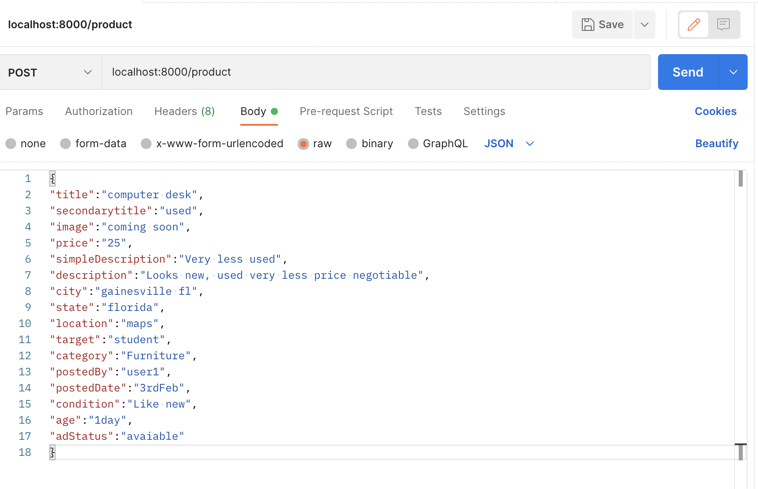

Fields such as “Title”, “secondary title”, “image”, ” price”, ”simple description”, ”description”, ”city”, “state”, “location”, “target”, “category”, “posted by”, “posted date”, “condition”, “age”, and “adstatus” can be filled to create a post.

By hitting this endpoint, the advertisement is created and added to the database, and success response code **200 OK** is displayed on the screen.

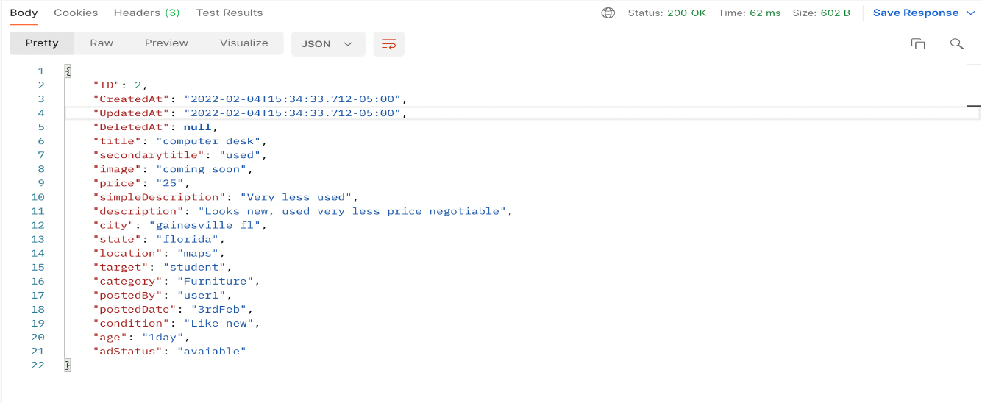

Advertisement has been added into the database

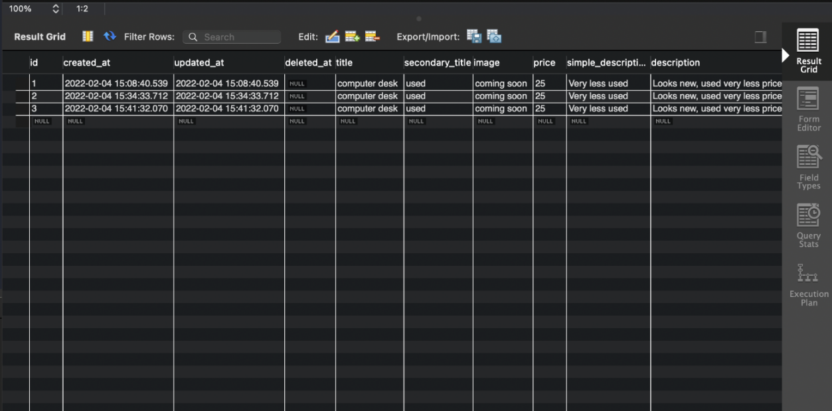

“/products”: ***(Get Method)*** This endpoint returns all the products that are currently listed on the website.

The endpoint **localhost:8000/products** are used to get all advertisements and the sample is given below

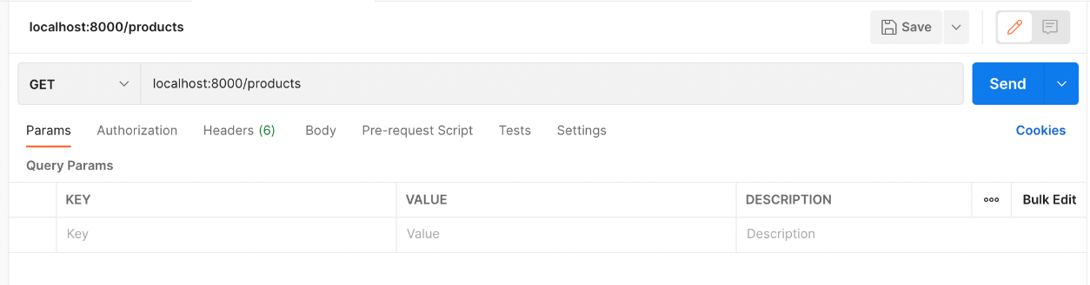

By hitting this endpoint, all advertisements are retrieved, and the response code **200 OK** is displayed.

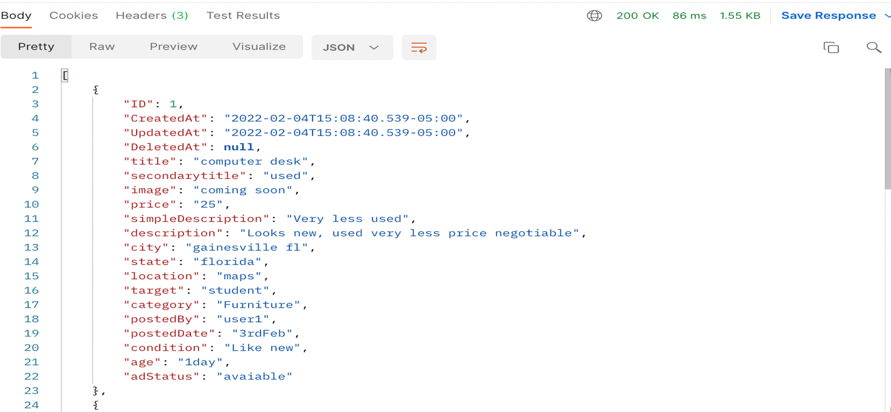

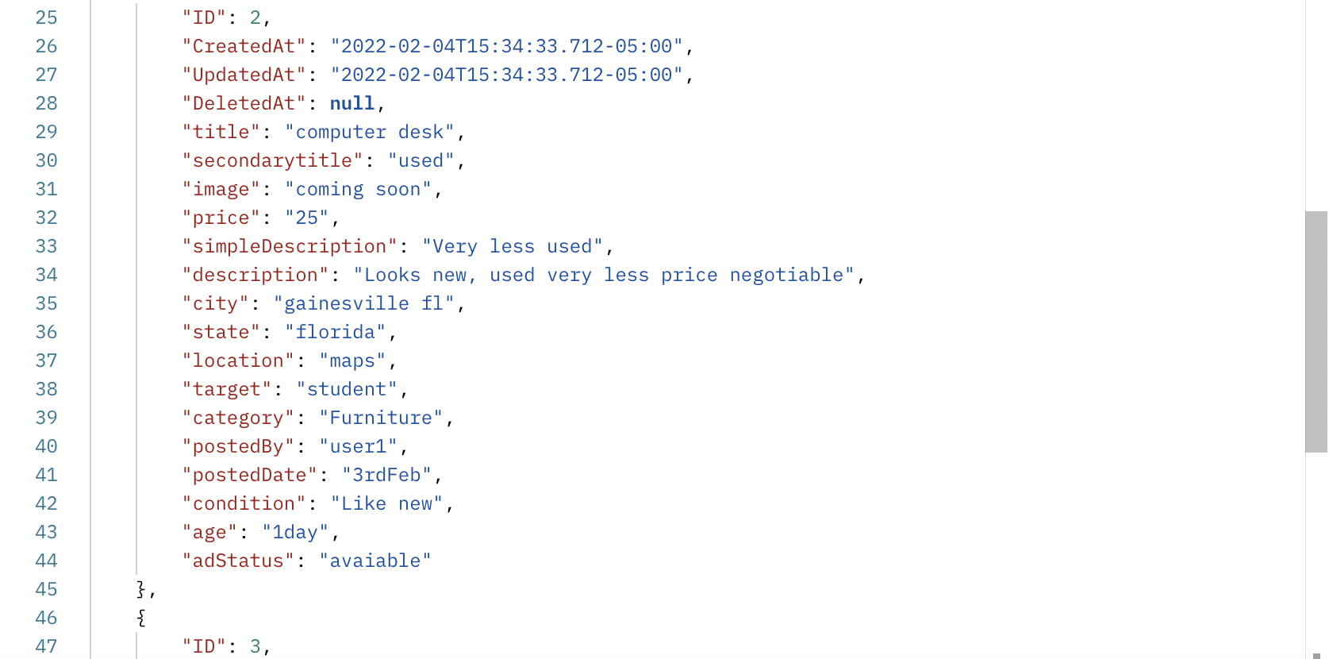

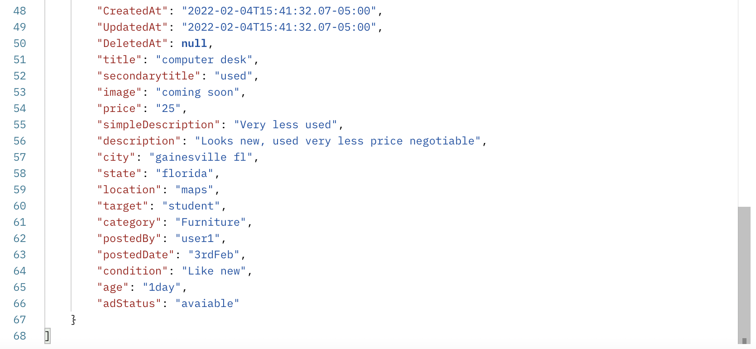

Steps to Compile and Run:

1. Navigate to the “backend” folder.
2. Run the following command in the terminal to start the server:

***go run main.go***

***go mod init***

The above command is used to create go.mod file which acts as a tracker for the dependencies.

1. Navigate to the “frontend” folder.
2. Run the following command in the terminal to compile the frontend code and render it in the browser:

***ng serve***

1. View the application by going to the address mentioned in the terminal. Example: http://localhost:4200

Demo Videos:

FrontEnd 🡪 <https://drive.google.com/file/d/1H4q-aU_TZIqPZ-yFm8HLCq5YkgH0Toki/view?usp=sharing>

Backend 🡪 <https://drive.google.com/file/d/1M4xew8792Bq1IFe_W-Z7YrSX_LGjBOTG/view?usp=sharing>